**Concept for Game (Title yet to be figured out)**

The Idea of this game is it is set in a world where windoze has taken over the complete planet and has taken upon itself to kill every other Operating system in a bid for world domination. It will be a 2d platform game. The unlikely hero is a “random_Nerd” that has to go around this dystopian world battling windoze icons and horribly disgusting windozers these unfortunate creatures have had their very life sucked out by the windoze evil corporation. The hero will run around this world collecting items to increase your score and life’s, make it through the level to battle the final boss in the hope that it will release the souls of the windozers.

Win condition : will be to get through the level and kill a final boss.  
Lose condition : get attacked by a windowzer thereby losing your soul to windoze, or falling off the platform.

I wrote some 8-bit style music for title and game over scene using fruity loops and some midi keyboards and some drum patches and some synth VST’.

To attack the “random_Nerd” will throw a Linux Penguin at the windozers freeing there soul and showing them that Linux is superior.

The overall theme I am hoping to convey is that it’s a dystopian world full of platforms and zombies

Ideas for the hero of the game:

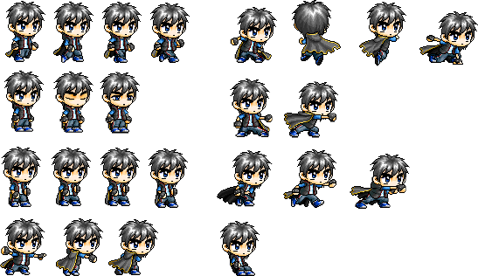

Reference for above image :

<http://lswbeast.deviantart.com/art/Zanpto-Sprite-Sheet-223506014>

Idea for the background:

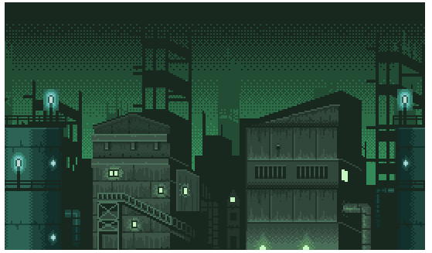

Reference for above image

<http://opengameart.org/content/industrial-parallax-background>

Windozers:

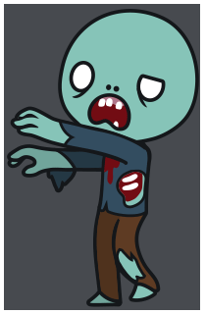

Reference for above image:

<http://opengameart.org/content/zombie-animations>

Sound when get windows icon

<http://www.winhistory.de/more/winstart/winstart.htm.en>

Font for game

<http://www.dafont.com/quiet-horror-story.font>